# PID Project – Notes

Slack notes on getting the dependencies working in VS2017:

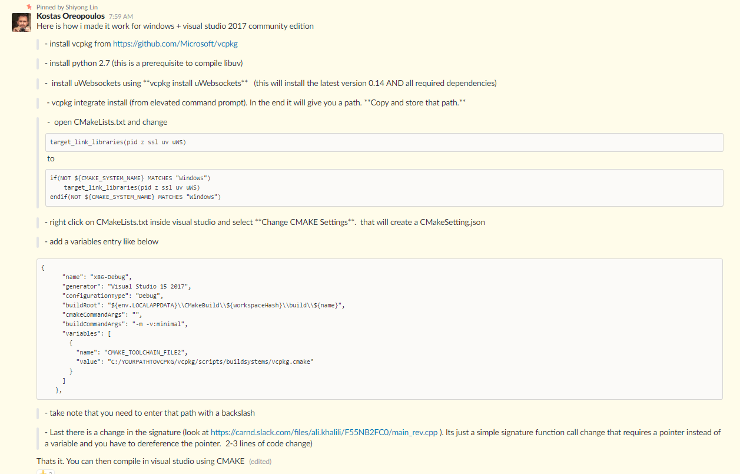

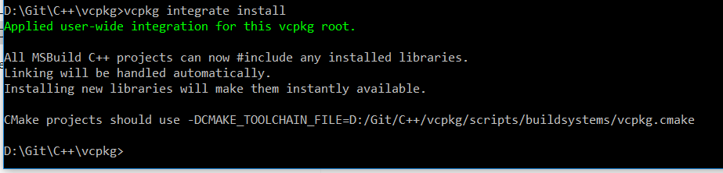

See main_rev.cpp for referenced changes.

Cmakefile.txt changes:

if(NOT ${CMAKE_SYSTEM_NAME} MATCHES "Windows")

target_link_libraries(pid z ssl uv uWS)

endif(NOT ${CMAKE_SYSTEM_NAME} MATCHES "Windows")

Variables:

{

"name": "x86-Debug",

"generator": "Visual Studio 15 2017",

"configurationType": "Debug",

"buildRoot": "${env.LOCALAPPDATA}\\CMakeBuild\\${workspaceHash}\\build\\${name}",

"cmakeCommandArgs": "",

"buildCommandArgs": "-m -v:minimal",

"variables": [

{

"name": "CMAKE_TOOLCHAIN_FILE2",

"value": "C:/YOURPATHTOVCPKG/vcpkg/scripts/buildsystems/vcpkg.cmake"

}

]

},